

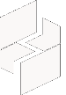

MICROSOFT ARCHITECTURE BEST PRACTICE FOR CLOUD AI PLATFORM
USECASE: ANALYTICS END-TO-END WITH MICROSOFT FABRIC

Document Title | Microsoft Cloud Center of Excellence Overview
Presales/Technical Head | Tushar Mehrotra/Rohit Pandey
CCoE Lead | Ravishankar N
Creation Date | December 2025
Version | Description | Modified by | Date | Approved by | Date
1 | Initial Architecture design | Ranu Kumar | 15/12/2025 | Ravi Shankar | 15/12/2025
2 | Environment and Workspace Design | Ranu Kumar | 15/02/2026 | Ravi Shankar | 15/02/2026
3 | Reusability and Extension | Ranu Kumar | 29/04/2026 | Ravi Shankar | 29/04/2026
Contents
1
1. Executive Summary 3
2. Scope and Applicability 3
3. Business Scenario Overview 3
4. Reference Architecture Overview 4
4.1 Architecture Description 4
5 Logical Architecture Components 4
5.1 Data Sources 4
5.2 Ingestion Layer 5
5.3 Storage Layer – OneLake (Lakehouse) 5
5.3 Semantic and Consumption Layer 5
6 Architectural Best Practices 6
6.1 Data Lifecycle Management 6
6.2 Environment and Workspace Design 6
- Reusability and Extension …………………………………………………………………………………………………7
10 Conclusion 7

Analytics end-to-end with Microsoft Fabric

Executive Summary
This document defines a standardized end-to-end data platform reference architecture built on Microsoft Azure and Microsoft Fabric. It provides architectural guidance and best practices for designing, building, and operating scalable analytics platforms that support batch, streaming, and advanced analytics workloads.
The architecture reflects established Microsoft design patterns for modern data platforms, while being curated and maintained internally to ensure consistency across solution designs, delivery engagements, and operational models.

Scope and Applicability
This reference architecture applies to:
- Enterprise and domain-oriented analytics platforms
- Data modernization and consolidation initiatives
- Batch and near real-time data processing scenarios
- Structured, semi-structured, unstructured, and streaming data
- Reporting, analytics, and AI-enabled insight solutions
The design supports multi-region deployments and can be adapted to meet regulatory, compliance, and data residency requirements across industries.

Business Scenario Overview
Organizations collect data from a diverse ecosystem of applications, operational systems, digital platforms, and external sources. Delivering timely and trustworthy insights requires a platform that can ingest data once, process it efficiently, and serve multiple analytical use cases without unnecessary duplication or complexity.
A modern end-to-end data platform on Microsoft Azure enables:
- Consolidation of data ingestion across batch and streaming sources
- Centralized storage using open, analytics-optimized formats
- Multiple analytics engines operating on a shared data foundation
- Secure and governed self-service analytics for business users
- A scalable foundation for advanced analytics and AI workloads

Reference Architecture Overview

Architecture Description
The architecture follows the complete data lifecycle from ingestion to insight, using Microsoft Fabric as the integrated analytics layer and Azure services to support ingestion, streaming, governance, and security capabilities.
High-Level Architectural Flow
- Data is ingested from source systems using managed batch and streaming services
- Ingested data is stored centrally in OneLake using a lakehouse pattern
- Data is transformed and enriched using Spark and SQL processing engines
- Curated datasets are exposed through semantic models and analytics endpoints
- Insights are delivered through reporting, dashboards, and advanced analytics workloads
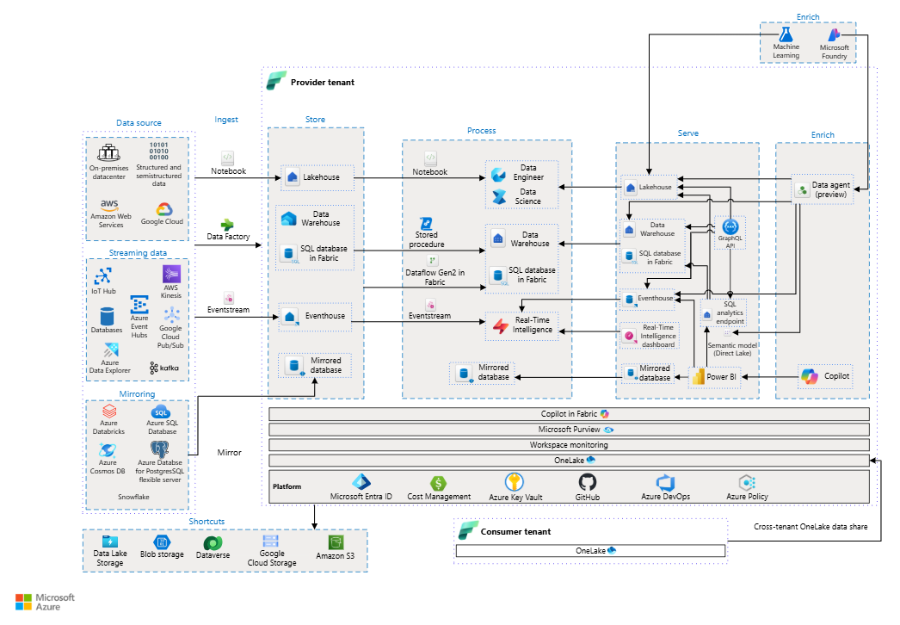

Logical Architecture Components

Data Sources
The platform supports a wide variety of data sources, including:
- Line-of-business systems such as ERP and CRM applications
- Cloud and on-premises relational databases
- Semi-structured and file-based data sources
- Event streams and real-time data producers
This flexibility enables organizations to integrate analytics across heterogeneous environments.

Ingestion Layer
Data ingestion and integration are implemented using managed Azure and Fabric services, providing:
- Orchestrated batch ingestion pipelines
- Event-driven ingestion for near real-time scenarios
- Connectivity to on-premises and multi-cloud environments
- Built-in reliability, monitoring, and error handling
Ingestion processes are designed to be scalable, observable, and repeatable.

5.3 Storage Layer – OneLake (Lakehouse)
All analytics data is stored in OneLake, which acts as the unified data foundation for the platform. Data is organized using a lakehouse pattern with clearly defined zones:
- Raw Zone – Data stored in its original, source-aligned structure
- Refined Zone – Cleansed and standardized datasets
- Curated Zone – Analytics-ready data optimized for reporting and consumption
Open data formats such as Delta Lake are used to support transactional consistency, schema evolution, and long-term interoperability.
Processing and Analytics Layer
The platform supports multiple analytics engines operating directly on OneLake data:
- Distributed Spark workloads for large-scale data transformation
- SQL analytics endpoints for relational queries and integration scenarios
- Shared execution models that minimize data movement and duplication
This approach allows different teams and personas to work on the same datasets using familiar tools.

Semantic and Consumption Layer
Curated data is made available to consumers through:
- Power BI semantic models
- Interactive dashboards and analytical reports
- Secure, role-based access to shared datasets
Where appropriate, Direct Lake access is used to provide high-performance analytics with reduced latency.
Advanced Analytics and Real-Time Processing

The architecture supports advanced and high-value analytics scenarios, including:
- Real-time analytics over streaming data
- Exploratory analysis using notebooks
- Machine learning model development and scoring
- AI-assisted analytics and Copilot-enabled experiences
All advanced workloads operate on governed data to ensure consistency and trust.

Security, Governance, and Compliance
Security and governance are embedded throughout the platform:
- Identity and access management using Microsoft Entra ID
- Role-based access control across workspaces and data assets
- Encryption of data in transit and at rest
- Data classification, sensitivity labeling, and lineage tracking
- Centralized monitoring and administrative controls
These capabilities ensure that the platform remains secure while enabling controlled self-service analytics.

Architectural Best Practices

6.1 Data Lifecycle Management
- Clearly define data zones and ownership responsibilities
- Retain raw data for auditability and reprocessing
- Apply consistent data quality and validation standards

6.2 Environment and Workspace Design
- Separate development, testing, and production environments
- Organize workspaces by data domain or functional area
- Apply standardized naming, access, and deployment patterns
- Performance and Scalability
- Optimize transformations using distributed processing frameworks
- Use shared compute and Direct Lake where applicable
- Monitor workload performance and capacity utilization continuously
- Operational Excellence
- Implement monitoring and alerting for ingestion and analytics workloads
- Maintain operational documentation and runbooks
- Regularly review and optimize pipelines, models, and reports
- Reusability and Extension
This reference architecture is designed to be reused and adapted across multiple initiatives, including:
- Enterprise analytics platforms
- Domain-specific data products
- Real-time analytics and event-driven systems
- AI and machine learning solutions
The modular design allows incremental adoption while preserving architectural consistency.

Conclusion
The end-to-end data platform architecture described in this document provides a scalable, governed, and future-ready foundation for analytics and AI workloads on Microsoft Azure. By standardizing on well-established architectural patterns and best practices, the organization can deliver reliable insights, reduce operational complexity, and support evolving business needs.

